*Android TableLayout going to be arranged groups of views into rows and columns. You will use the <TableRow> element to build a row in the table. Each row has zero or more cells; each cell can hold one View object.*

TableLayout containers do not display border lines for their rows, columns, or cells.

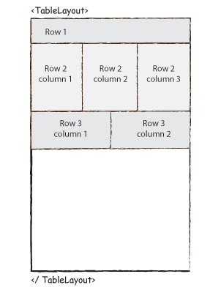

TableLayout Attributes

Following are the important attributes specific to TableLayout −

|  |  |
| --- | --- |
| **Sr.No.** | **Attribute & Description** |
| 1 | **android:id**  This is the ID which uniquely identifies the layout. |
| 2 | **android:collapseColumns**  This specifies the zero-based index of the columns to collapse. The column indices must be separated by a comma: 1, 2, 5. |
| 3 | **android:shrinkColumns**  The zero-based index of the columns to shrink. The column indices must be separated by a comma: 1, 2, 5. |
| 4 | **android:stretchColumns**  The zero-based index of the columns to stretch. The column indices must be separated by a comma: 1, 2, 5. |

Following is the content of the modified main activity file **src/com.example.demo/MainActivity.java**. This file can include each of the fundamental lifecycle methods.

package com.example.demo;

import android.os.Bundle;

import android.app.Activity;

import android.view.Menu;

public class MainActivity extends Activity {

@Override

protected void onCreate(Bundle savedInstanceState) {

super.onCreate(savedInstanceState);

setContentView(R.layout.activity_main);

}

}

Following will be the content of **res/layout/activity_main.xml** file −

<TableLayout xmlns:android="http://schemas.android.com/apk/res/android"

android:layout_width="fill_parent"

android:layout_height="fill_parent">

<TableRow

android:layout_width="fill_parent"

android:layout_height="fill_parent">

<TextView

android:text="Time"

android:layout_width="wrap_content"

android:layout_height="wrap_content"

android:layout_column="1" />

<TextClock

android:layout_width="wrap_content"

android:layout_height="wrap_content"

android:id="@+id/textClock"

android:layout_column="2" />

</TableRow>

<TableRow>

<TextView

android:text="First Name"

android:layout_width="wrap_content"

android:layout_height="wrap_content"

android:layout_column="1" />

<EditText

android:width="200px"

android:layout_width="wrap_content"

android:layout_height="wrap_content" />

</TableRow>

<TableRow>

<TextView

android:text="Last Name"

android:layout_width="wrap_content"

android:layout_height="wrap_content"

android:layout_column="1" />

<EditText

android:width="100px"

android:layout_width="wrap_content"

android:layout_height="wrap_content" />

</TableRow>

<TableRow

android:layout_width="fill_parent"

android:layout_height="fill_parent">

<RatingBar

android:layout_width="wrap_content"

android:layout_height="wrap_content"

android:id="@+id/ratingBar"

android:layout_column="2" />

</TableRow>

<TableRow

android:layout_width="fill_parent"

android:layout_height="fill_parent"/>

<TableRow

android:layout_width="fill_parent"

android:layout_height="fill_parent">

<Button

android:layout_width="wrap_content"

android:layout_height="wrap_content"

android:text="Submit"

android:id="@+id/button"

android:layout_column="2" />

</TableRow>

</TableLayout>

Following will be the content of **res/values/strings.xml** to define two new constants –

<?xml version="1.0" encoding="utf-8"?>

<resources>

<string name="app_name">HelloWorld</string>

<string name="action_settings">Settings</string>

</resources>

Let's try to run our modified **Hello World!** application we just modified. I assume you had created your **AVD** while doing environment setup. To run the app from Android Studio, open one of your project's activity files and click RunEclipse Run Iconicon from the toolbar. Android studio installs the app on your AVD and starts it and if everything is fine with your setup and application, it will display following Emulator window −

